Historic Redford Theatre's
80th Anniversary Program:
80 Years Under the Stars: A Gala Celebration

April 19, 2008

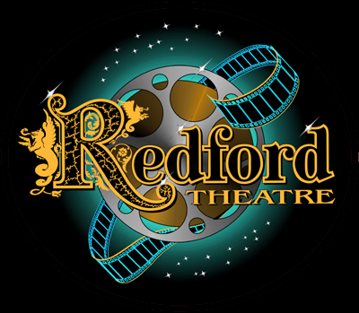
80th
Anniversary
1928-2008
Historic

The Historic Redford Theatre Sponsor:_________________________________
owned and operated by the
Motor City Theatre Organ Society, Inc. _________________________________

_________________________________
Tickets: 313-333-0080
Attention: _________________________
Theatre Contacts:
Dave Martin: 586-808-9807 Telephone: (_______) _______________
Janice McNiel: 734-425-7276

Be a Part of the Souvenir Program!

Please Choose Level of Sponsorship:

______ Memories/Greetings Ad ($15.00) _______ Galaxy Level ($100-$299)

______ Star Level ($25-$49) _______ Seat Sponsor Special** ($300+)

______ Shooting Star Level ($50-$99) **Plaque with name and 80th Anniversary placed on
standard seat in the Historic Redford Theatre

Share a special memory at The Redford, extend congratulations, or just say hello. Place your ad in the Memories and Greetings section of the Program:

____________________________________________________________________________________

____________________________________________________________________________________

____________________________________________________________________________________

Amount enclosed: $_________________________

Please make check payable to the Motor City Theatre Organ Society, Inc. Donations must be received by March 28, 2008 to guaranty inclusion in the Souvenir Program:

80th Anniversary Celebration
Redford Theatre

17360 Lahser
Detroit, MI 48219
Thank you for your support!

